**6. Control**

Following the inspection and assessment of the various sensor measurements and characteristics, an algorithm is required to control the system in the most ideal manner. Firstly, before applying control, a method of capturing information regarding the exact position of the white line is necessary. In this case, the chosen TCRT5000 optical sensor is responsible for this operation using its infrared emitter and phototransistor detector. Basically, the led emits infrared radiation that’s only reflected off a white surface back to the detector. The detector outputs a high voltage or a low voltage depending on the surface the sensor is positioned over directly. Multiple sensors aid the whole process which will be discussed later.

In terms of wheel control, a method is essential to ensure buggy movement occurs in both the right direction and speed. The direction is controlled using the H-bridge circuit embedded within the motor drive board in which a unipolar or bipolar mode is chosen. The choice is implemented by driving the digital output pin on the Nucleo board to operate in either modes. Wheel speed control is executed using a pulse width modulation (PWM) signal for each wheel separately. The PWM is configured depending on the sensor feedback which in return controls the duty cycle for each motor connected to each wheel. The resulting output is a constant, increase or decrease in each wheel’s speed to direct the buggy back on track.

**6.1 Proportional vs Bang-Bang**

In terms of control, Proportional and bang-bang algorithms are two theories which represent different approaches and demonstrate dissimilar functionality. A bang-bang controller switches severely between on and off states which could be very useful in certain situations where a quick, abrupt reaction is mandatory, as in the case of brakes. In other instances, bang-bang largely limits the flexibility of a system forbidding any inter-state regions. Looking at programming, bang-bang is simpler to implement and work with compared to the Proportional controller. For the Proportional controller, the control is more reliable as it illustrates greater accuracy and precision. Error is dealt with a better handling that gives rise to a smoother, desired output. Drawbacks could be the complexity of the program and the lateness of response in toggling environments.

**6.2 P, I and D in PID controllers**

A practical method of implementing continuous control is a proportional-integral-derivative controller. Each term in the PID controller adds a specific functionality and could be advantageous or not depending on the certain situation or system. In general, the P corrects current error, the Integral looks at previous errors and the derivative predicts future errors.

The P term allows the controller to maintain stability of process by decreasing the error under steady state. However, the error is not entirely eliminated, and amplification of background noise is considered a main flaw. When minimal conditions are met, and system is lenient with steady state error, P controllers work greatly. The integral term solves the issue of the steady state error by rejecting and excluding it completely. This works at the optimum when the error margin is small, and the integral builds up a memory of all these deviations. However, if huge errors are continual, the integral could respond undesirably by overshooting in the opposite side in order to counter the large error. In terms of speed, the integral takes time to build up and so could affect negatively if quick motion is a requirement. The final term, the derivative, has the effect of predicting future errors and so is advantageous when speed is needed. A useful application is when the error is better than the previous one in which the derivative makes sure nothing is made to correct the error. Although it works well to prevent immediate deviations, the derivative amplifies the noise directly causing problems if used as PD controller [1].

**6.3 Control strategy for each problem**

A number of variables and components will have to controlled to influence the nature of the control algorithm. The direction and speed of the buggy movement form the basis of the control theory needed for implementation. Controlling the wheel direction works by controlling the motor through the drive board electronics. This is performed by the h-bridge circuit in which a unipolar mode is a superior operation, in this case, to reduce the power loss problems through lower conduction losses. On the other side, a PID controlling algorithm would help with the wheel direction control by increasing the accuracy of the line-sensing movement. This method overcomes the problem associated with the ban-bang controller in which the zig-zag movement is eliminated, and increased smoothness is outputted.

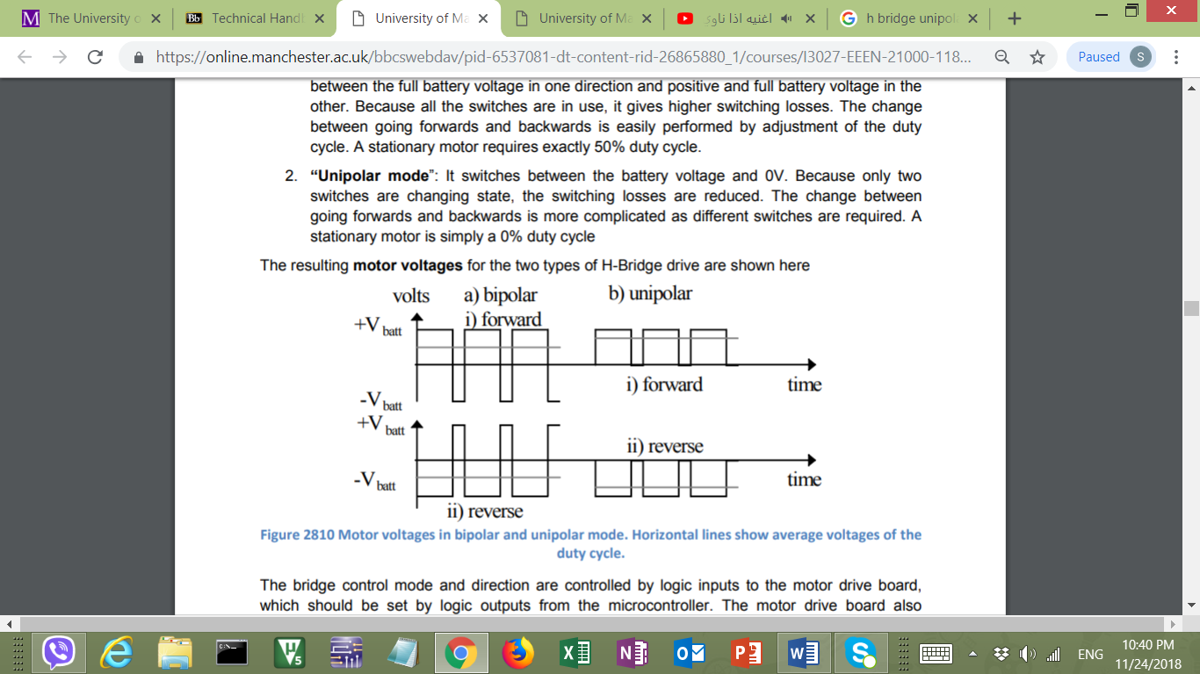

Figure 6.1 shows both unipolar and bipolar modes in forward direction

Figure 6.1 shows the unipolar signal varies between 0 V and ±V batt instead of the complete amplitude in both sides which ensures less switching power loss.

Another variable to be controlled is the wheel speed which is performed by controlling the motor linked to that wheel. The value of the PWM applied to each motor depends on what speed is needed to maintain track guidance. This is done by referring to the light sensor values along with the current wheel speed given by the encoders discussed in section 5.

**6.4 Algorithm’s relation to sensor design**

Several control strategies could be implemented depending on the available sensor characteristics and behaviour. Different controllers operate ideally with different sensor designs and vice versa. Digital control works better with certain line sensors that demonstrate abrupt change in voltage measured when moving from black to white, in this case. On the other side, sensors that inhabit a very wide line spread function could work well with analogue control, improving accuracy. Moreover, bang-bang controllers adapt well when few sensors are used, limiting further functionality. However, PID controllers demonstrate their strengths when higher numbers of sensors are used to interpret the error better. These factors illustrate the close, direct relationship between the choice of control and the sensor model.

The choice of digital or analogue control affects the sensor set-up as the positioning of the middle light sensors depends heavily on it. For the digital implementation, the two middle sensors’ ideal position is at the centre of the white line to feedback the highest voltage whereas others give back nearly 0 V. In terms of analogue, the alignment of the two middle sensors right about the white-black edge helps measuring the relevance of the buggy to the white track. For the microcontroller interface, the number of sensors used affect how many pins are needed. Furthermore, the switching between the various sensors’ readings could require the use of a Darlington pair and comparators which affects the sensor circuit design.

**6.5 Proposed sensor implementation**

Following the previous discussed factors, the chosen line sensing set-up is composed of 6 TCRT5000 optical sensors. The sensor type is chosen based on the high white line detection accuracy compared to the other available measured line sensors. The performance of the TCRT5000 allows it to stand out as it’s line spread function and crosstalk graphs support the PID and digital controlling theory. In terms of the number geometry, higher number of sensors used increase the line detection accuracy of the buggy. As the sensor inputs an analogue value into the microcontroller, an two comparators are responsible for the analogue-digital conversion. From figure ??? above, the threshold voltage is set as ??? V as to any sensor value below that suggest the sensor is above a black area and is given a logic level ‘0’. Above that value, logic level is ‘1’ and this implies the specific sensor is directly above the white line. For the microcontroller interface, 6 Digital Inputs will be used for the 6 line sensors. Figures 6.2 and 6.3 below show the sensor set-up over various track positions, implementation is justified based on the planned digital control approach.

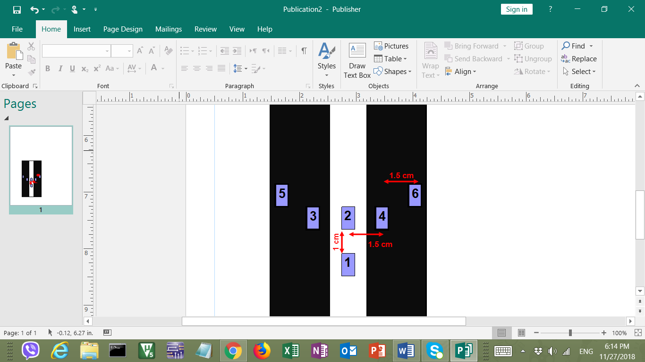

Figure 6.3 sensor set-up over gentle curve

Figure 6.2 sensor set-up over straight

**6.6 Control implementation plan**

To initialise the control, the first step is to ensure straight movement occurs when both sensors 1 and 2 return ‘1’ while others return ‘0’. This is shown in figure 6.2, where an application of equal PWM of around 50% duty cycle on both motors resolves the issue. Building on that, bends of maximum 45º provide a control complication, illustrated in figure 6.3. Assuming a right curve as above, a gentle bend is detected by sensor 4 as well as sensors 1 and 2, in which a PWM of 50% maintains on the left wheel, however, the right wheel’s PWM is reduced to 20% duty cycle to slow it down and aid slight right turn. In the race, a possible great bend requires a 30% PWM on the left wheel with 0% level or even braking on the right wheel [1]. This is applied following the feedback of logic level ‘1’ from sensor 6 along sensors 1,2 and 4. All previous strategy will be implemented for the left turning with correspondence with the opposite wheels and sensors. To ensure smoothness of the above strategy, a PID controller will be used for error elimination with assessment of current, past and future errors. The controller, programmed in C++, will be positioned as in figure 6.4 below where the controller will be used to improve the sensing accuracy. Tuning of the controller will follow the Ziegler–Nichols method, with extra modification, to get the $K_{P}, K_{i}$ and $K_{D}$ constants required.

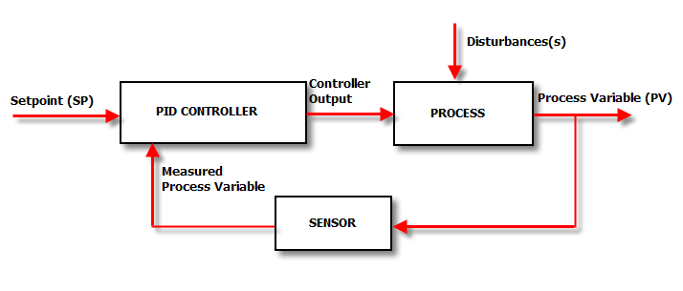

Figure 6.4 Control process overview [2]

In dealing with direct sunlight, the TCRT5000 have no problems as the sensors will be taped and covered to avoid outer influence. Finally, regarding the line breaks within the track, sensors 1 and 2 are distanced 1 cm apart to ensure the 6 mm gaps are irrelevant.

References:

[1] InParmix(2018)<http://www.inpharmix.com/jps/PID_Controller_For_Lego_Mindstorms_Robots.html> [Accessed: 22/11/2018]

[2] Control Solutions Minnesota (2018) <https://www.csimn.com/CSI_pages/PIDforDummies.html> [Accessed: 25/11/2018]